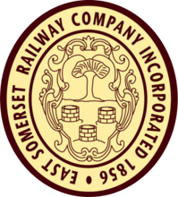
School Visits Booking Form
Please complete and e-mail to education@eastsomersetrailway.com
School: |  | Visit Date (Weds only):
Postcode: |  | Departure Time:
Contact Name: |  | Age of Children:
Contact Number: |  | Number of Children:
E-Mail: |  | Number of Adults:

Learning Themes  (please choose one) |  | Special Sessions (optional)  (please choose one) |  | Site Attractions  (please choose two)
 | X |  | X |  | X
Evacuees |  | Victorians and Influenza |  | Signal Box
Victorian Life |  | Life in Shepton Prison |  | Miniature Railway
Women and Railways |  | Railway Roles |  | Engine Shed
Transport Through Time  Canals Turnpikes Trains |  | Conservation in Africa  (David Shepherd) |  | Sentinel Diesel Museum
Home Front : Bristol Blitz |  | Station Master’s Trail
Brunel and the West Country |  | Handling Evidence
Protest and Powder Kegs
The train journey lasts approximately 40 minutes.
Please note below any medical, access or learning differences:
Office Use Only
Admin approved |  | Confirmation received
Entered on calendar |  | Deposit paid (amount)
Schedule sent to staff involved |  | Balance received (amount)
Lunch arrangements |  | Schedule sent to school
Will school allow photography? |  | Risk assessment sent to school
Names of participating ESR Staff :

